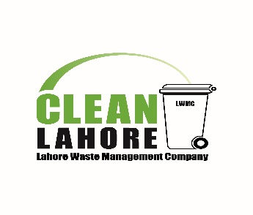 | LAHORE WASTE MANAGEMENT COMPANY  Lahore, Pakistan

INVITATION FOR INTERNATIONAL PRE-QUALIFICATION
FOR
SUPPLY, INSTALLATION & OPERATION AND MAINTENANCE OF AUTOCLAVE BASED HEALTHCARE WASTE TREATMENT FACILITY FOR INFECTIOUS HOSPITAL WASTE IN LAHORE, PAKISTAN

LWMC invites sealed applications for Pre-Qualification from national/international firms/Joint ventures/Consortiums/Companies for said project in Lahore, Pakistan.
Interested parties may download the pre-qualification documents from www.lwmc.com.pk. Last date of submission of application is not later than 1500 Hours, 13th November, 2017 on following address.
General Manager (Procurement & Contracts)
M/S Lahore Waste Management Company
4th Floor, Shaheen Complex, Edgerton Road, Lahore-Pakistan
Tel: 92 42 99205153-55 Fax: 92 42 99205156
Email: procurement@lwmc.com.pk

